IT2100 -Employability Skills Development
Faculty of Computing

SLIIT

Personal Development Plan (PDP)
Student Name: K.H.S Dinsara
Student ID: IT23588714
Degree: BSc (Hons) in Information Technology
Year: 2
Semester: 2
Contents
01.Self-Assesment 3
01.1. Strengths and weaknesses 3
01.2. Personality traits 3
01.3. Skills audit 4
02.Goal Setting 4
03.Action Planning 5
04.Monitoring & Evaluation Strategy 6
05.Personal Insight & Motivation 6
06.Presentation & Communication 7
07. Use of Tools & Evidence 7

01.Self-Assesment
To gain a general idea of my current strengths and areas for development, I conducted thorough self-assessment using the SWOT (Strengths, Weaknesses, Opportunities, Threats) analysis approach in conjunction with skills assessment according to the Johari Window model. Part of reflective practice involved seeking feedback from peers, lecturers, and family members in order to determine blind spots in the way that I see myself, for fair and unbiased analysis of my academic, personal, and professional attributes.

01.1. Strengths and weaknesses
My greatest strengths are my technical and analytical skills. I can program in languages such as Java, C, C++, and SQL, learned through university modules and side projects like developing a Java backend web project. I have very good problem-solving skills, which have been illustrated by debugging complex code efficiently, and I am very adaptable, learning new things rapidly as evidenced by rapid adjustment to online learning during the pandemic. My learning preference is visual-kinesthetic, performing best in hands-on coding environments rather than theoretical lectures.
However, there are flaws in soft skills and also in a few technical areas. Effective communication, particularly in groups, is one of my weaknesses as my introverted nature keeps me tardy to present ideas, receiving lower participation scores in group assignments. Time management is also one of my weaknesses, where I procrastinate over non-technical matters with the consequence of rushing through submissions. Personally, I am not familiar with advanced technologies like AI ethics and cybersecurity at beyond basic levels, and I have underdeveloped leadership skills as I avoid dominating collaborative tasks. The Johari Window feedback showed that others perceive me as reliable but sometimes aloof, highlighting a need to develop interpersonal rapport.

01.2. Personality traits
There are galore opportunities in my environment in SLIIT, including free online courses offered by Coursera and LinkedIn Learning, technology workshops organized by the university, and internship with corporate partners like Virtusa. Networking sessions and hackathons give opportunities to develop my portfolio. Threats include the fast growth of IT, where technologies like AI and blockchain can make distant learning skills obsolete if not updated, intense competition from foreign-certified job applicants, and economic uncertainty in Sri Lanka that will limit internship opportunities.

01.3. Skills audit
The skills assessment, done through a self-assessment scale of 1-10 with support of feedback, rated me high on technical skills (8/10) but low on communication (4/10), teamwork (5/10), time management (5/10), and leadership (7/10). These deficiencies feed directly into my development priorities, with my PDP reflecting employability weaknesses in a comprehensive way.

02.Goal Setting
Building directly on my self-evaluation, I have used the SMART framework to establish goals that are Time-bound, Relevant, Specific, Measurable, and Achievable. My passion for AI-driven solutions is in line with these aims, which focus on short-term (6–12 months), medium-term (1-3 years), and long-term (3-5 years) perspectives while bridging recognized shortcomings with strengths.
Short-term objectives
By October 2025, improve communication skills by taking part in three or more group presentations and receiving a feedback score of seven out of ten or higher from peers. To close my technical knowledge gap, finish my Coursera online certification in AI ethics by December 2025.

Medium-term objectives
Apply to at least five businesses, find a Software Engineering-focused internship by the middle of 2027. By the conclusion of Year 3, demonstrate leadership by taking charge of one university club activity, such planning a tech seminar.
Long-term objectives
By 2030, I want to work full-time as a Full stack developer for a reputable company like Virtusa or WSO2, with a portfolio that includes two GitHub projects that have been published.

03.Action Planning
My action plan includes specific timetables, milestones, and resources to guarantee viability, along with realistic, step-by-step tasks to accomplish the goals.
I will join the SLIIT AIESEC Club in October 2025 in order to improve my communication skills. I will attend weekly meetings and give one speech every month. Resources include lecturer feedback sessions, and free club membership .I will enroll in the Coursera course "AI For Everyone" by September 2025 and devote five hours each week to modules and tests in order to earn the AI Ethics certification.

Goals
Complete half of the course by October 2025 and pass the last test by November. Resources include online discussion forums, study groups, and access to Coursera offered by the university.
For the internship, I will update my CV and LinkedIn by December 2025, attend two career fairs in 2026, and apply to targeted companies like Code-Gen.
Milestones
Network with 10 professionals by March 2026 and secure interviews by June 2027.To build leadership, I will volunteer for the IT Society committee by January 2026, organizing one event like a coding workshop.

04.Monitoring & Evaluation Strategy
I'll put in place a systematic monitoring system that prioritizes self-control and flexibility in order to keep tabs on developments and uphold accountability.
External feedback is sought through evaluation techniques such as self-scoring against initial skills audit standards, mentor check-ins for leadership activities, and peer reviews following presentations. I will reallocate time or resources, such as extending a deadline by one month or moving to different courses to keep the PDP fresh and useful, annual reassessments will take into account fresh perspectives, such as internship comments.

05.Personal Insight & Motivation
I am motivated by a strong desire to use technology to address pressing issues, especially in the fields of artificial intelligence (AI) and such as data-science, where morality may avert societal injustices like data breaches. My passion for this topic was sparked by personal events, such as seeing a family member's data stolen, and as an INTJ, I see myself working as an architect of safe AI systems that enable companies while protecting privacy.

These objectives are not random rather, they are a reflection of my basic principles of honesty and creativity, transforming my shortcomings into assets in order to realize my life's mission of supporting Sri Lanka's digital economy. My proactive engagement steady academic achievement demonstrate my self-motivation, which helps me overcome obstacles. I'm excited about this PDP since it's a personal growth roadmap that will turn isolation into cooperation and nervousness into confidence.

06.Presentation & Communication
For clarity and logical flow, this PDP is organized using bullet points, bold headings, and numbered parts. While a Gantt chart visually depicts timeframes, concise words guarantee reading. Using programs like Grammarly, grammar and spelling have been carefully examined while preserving formal language free of jargon. By clearly connecting portions, coherence is attained, showcasing excellent communication abilities.

- Communication Goal: Oct 2025 (Join Club) - Dec 2025 (Feedback Milestone)
- AI Ethics Cert: Sep 2025 (Enroll) - Nov 2025 (Complete)
- Internship: Dec 2025 (Update CV) - Jun 2027 (Secure)
- Leadership: Jan 2026 (Volunteer) - End Year 3 (Evaluate)
- Long-term Role: Ongoing to 2030

07. Use of Tools & Evidence
I support my PDP with proof such as a screenshot of my revised LinkedIn profile.

- GitHub Account
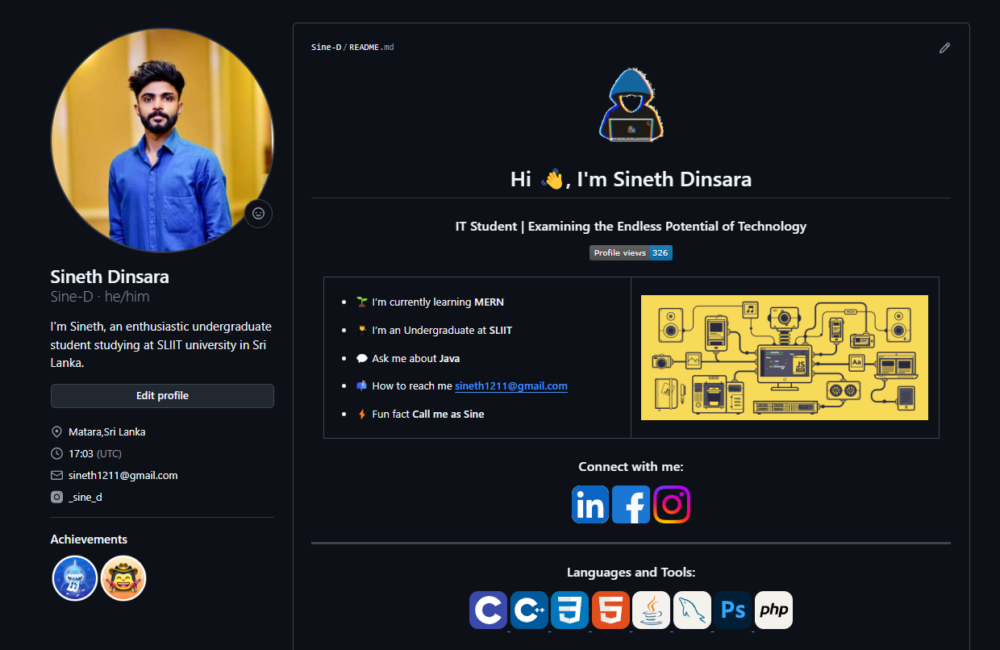

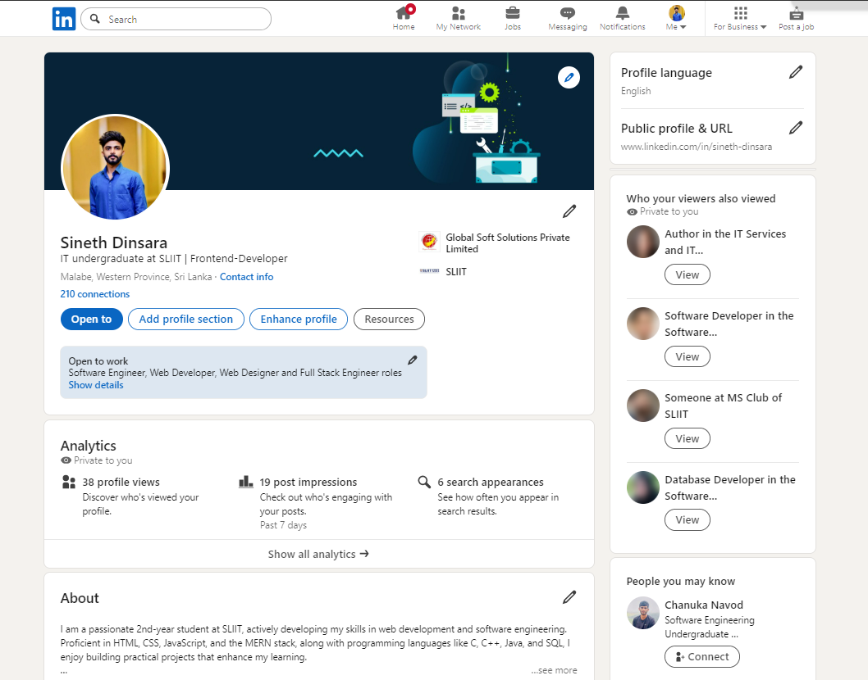
- LinkedIn Account

